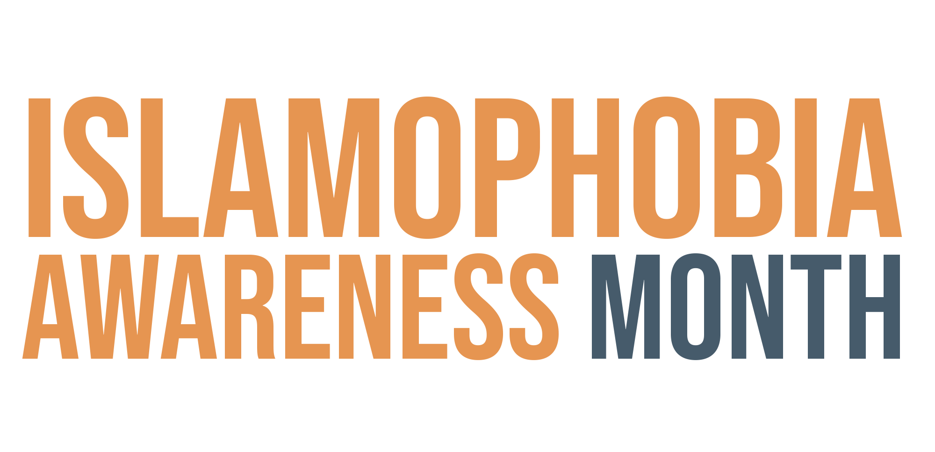

Webinar - Key messages

About MEND

MEND stands for Muslim Engagement and Development which is a 100% community funded organisation which seeks to empower British Muslims across the UK to tackle Islamophobia by getting involved in media and politics.

About Islamophobia Awareness Month

Islamophobia Awareness Month (IAM) aims to deconstruct and challenge the stereotypes about Islam and Muslims.

The campaign, held every November, aims to work with stakeholders and community organisations to promote the positive contributions of Muslims in the UK as well as raise awareness of the threat of Islamophobia and encourage better reporting of incidents to the police.

Get Involved

Note: If webinar is 30 minutes long then this message should be mentioned at 15min mark and at the end. If 60 minutes, then message should be mentioned every 20 minutes roughly.

Volunteer with MEND

MEND prides itself in being a grass-root led organisation. There are dozens of local MEND teams across the UK fulfilling the organisations national vision at a local level. Our local teams bring together people from all walks of life including teachers, doctors, lawyers, finance professionals, entrepreneurs, housewives and students. To get involved visit https://www.mend.org.uk/get-involved/

Contribute

You can also get involved by joining our campaigns. IAM is our flagship campaign and you can get involved by organising an Islamophobia awareness event in your local community or at your place of work. To find out more visit http://islamophobia-awareness.org/ where there are template presentations and useful resources that can be downloaded

Donate

MEND is a 100% community funded organisation. We pride ourselves in being so because it allows us to have an independent voice and tackle the issues facing our community.

If you want to be part of the UK largest grass-root movement tackling Islamophobia in the UK and protecting our community then make a regular donation for as little as £3 a month. Visit https://www.mend.org.uk/donate

If you feel there should be other key messages on here please contact aman.ali@mend.org.uk

