

**Zahraa Ahmed**

**21.12.2017**

Islamophobia Awareness Month

**Central London Working Group Events for IAM 2017**

Contents

Introduction 2

1. Purpose of Report 3

2. What is Islamophobia Awareness Month? 3

Central London Events during IAM2017 3

1.      Hospital – Exhibition 4

2.      Ilmfest – IRU Stall 4

3.      Universities – Exhibitions and Presentations 5

4.  Mosques 6

1. Al-Manaar Mosque 6

2. Goodge Street Mosque 7

Conclusion 7

1.      How IAM 2017 went 8

Appendix 8

1. Table of Events during IAM2017 9

# Introduction

## Purpose of Report

This year, MEND’s Central London Working Group successfully organised ten events (see Appendix), with these ranging from ‘The Causes & Cures of Islamophobia’ presentation to self-defence classes at local Mosques. This report will not only provide a summary for the various events that were organised, but also demonstrate their relevance and how they appeal to the overall work MEND aims to accomplish.

## What is Islamophobia Awareness Month?

Established in 2012 by MEND and other British organisations, IAM aims to work with local governing officials, journalists and educational establishments to raise awareness and encourage both Muslims and non-Muslims to report incidents of hate crime that they may either experience or witness.

Taking place every November, Islamophobia Awareness Month (IAM) not only aims to demonstrate the reality of rising Islamophobia within the UK, but also challenges the negative stereotypes and attitudes facing the British Muslim community. The fact that IAM has become an essential event in the calendars of prominent Muslims organisations demonstrates MEND’s incredible success in legitimising its cause and in raising awareness for Islamophobia.

With over thirty different working groups situated across England, each group is responsible for not only working with local establishments to organise events for the month, but also raising awareness for the organisation itself. Together, these groups form the backbone of MEND and demonstrate how, by working with the local community, negative attitudes and better reporting of Islamophobia can be possible.

# Central London Events during IAM2017

## 1.      Hospital – Exhibition

The Central London Working Group kicked off their campaign for Islamophobia Awareness Month 2017 with their first event taking place at Whittington Hospital. Situated in North London, Whittington Hospital is an iconic institution for the area and its local residents.

The exhibition was displayed on Saturday the 4th of November from morning until the evening. The exhibition had a special significance to the hospital, with a section of the exhibition highlighting the contributions Muslims make to the National Health Service. By the Grace and Help of Allah the event was a great success.

This was the first time the Working Group aimed to display the exhibition outside the walls of a university campus. By extending outside of the university sphere, the Central London team were effectively able to target a new audience by putting up the exhibition in a place that was accessible to the public. As universities tend to be private institutions and access tends to be restricted to university students or staff members, the hospital lent itself as a perfect example of an institution that is open to a larger variety of individuals, many of whom may not be informed about Islamophobia and its rising prominence in society.

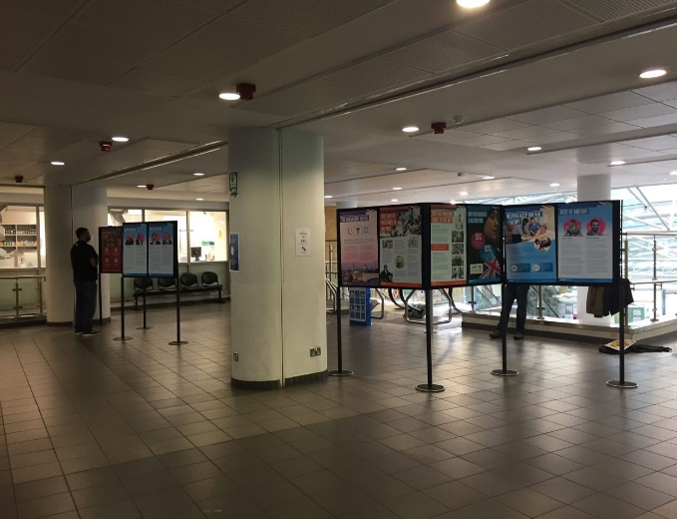

*Figure 2 -* Members of the public observing the exhibition

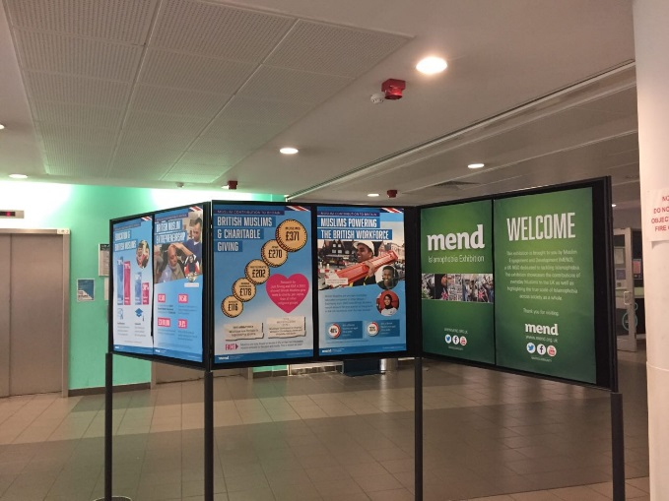

*Figure 1* - IAM Exhibition at Whittington Hospital

## 2.      Ilmfest – IRU Stall

Taking place at the O2 centre Greenwich, IlmFest attracts thousands of Muslims every year to attend various lectures from prominent Imams and Shaykhs from all over the globe. This year, MEND managed to secure a stall at the venue, which shed light on both the general work MEND does and the newly established Islamophobic Response Unit (IRU). The IRU aims to provide support and access to the appropriate resources to those who have been victims of Islamophobia.

Through the use of social media and by actively talking to attendees, the MEND Central London team was successful in raising the profile of the organisation to the many number of Muslims who had attended from across the country, thus demonstrating its immense success.

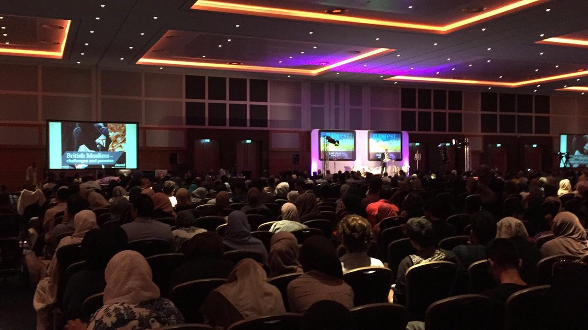

*Figure 3:* Ilmfest, London - An event which attracts a national audience

## 3.      Universities – Exhibitions and Presentations

Universities and university students have been the main target market for the Central London Working Group. As a result, displaying the exhibition at as many different university campuses was a fundamental aim and objective of the Working Group before coming into this month.

During November, the most popular event was the Islamophobia Awareness Exhibition. This exhibition aims to demonstrate both statistical figures of what Islamophobia looks like in the UK, whilst highlighting the various achievements Muslims have made to British society. In 2016, MEND’s Central London Working Group managed to successfully secure one institution to place the IAM exhibition. However, in **2017**, this increased to **4** institutions. Amongst this list were SOAS, Kings College London, University College London and Queen Mary London. It is important to stress that KCL, UCL and QMUL were all new universities that signed up to the campaign.

The placing of the exhibitions at prominent universities within London not only demonstrates the progress MEND has made in terms of starting these conversations, but also in raising awareness amongst those who may be unaware of how prominent Islamophobia is, both in wider society, but also on campus. Overall, this event was very successful in maintaining relationships with Islamic Societies, but also in the creation of relationships with the student unions at various institutes, thus allowing better communication for future events.

Along with the exhibition being displayed at various globally famous universities, the Central London Working Group also helped facilitate a Causes and Cures presentation at Queen Mary University.

The rise of exhibitions and events taking place in university settings is also important to note. Whilst universities have always been institutions for social movement and progress, it can be argued that discussions surrounding Islamophobia, especially those experiences built into the academic structure are often not addressed within these settings.

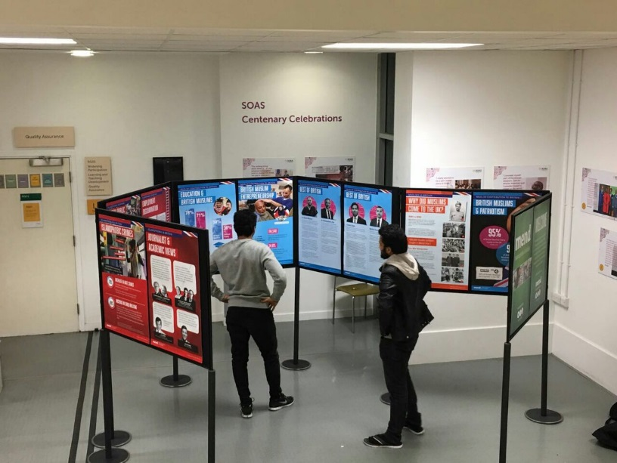

*Figure 4:* IAM Exhibition at SOAS, University of London

## 4.  Mosques

### Al-Manaar Mosque

The Central London Working Group continued to cement its close relationships with different Mosques around the capital. Al-Manaar Mosque was a primary example of this. Al-Manaar Mosque, which played a crucial role of humanitarian relief during the Grenfell fire, opened its doors again to serving to the wider community by allowing MEND to provide guidelines to combatting Islamophobia to the Muslim community.

The Causes and Cures of Islamophobia was successfully delivered as a presentation to around 40 people at the Mosque, during the weekend. This presentation was then followed by a self - defence class for sisters. Many found this to be a helpful resource in learning to defend themselves in potentially dangerous situations. As a result of these events, there was a growing interest in the work MEND does, with many inquiring about how to join working groups.Both events were organised by the women’s engagement team.

### Goodge Street Mosque

The second Mosque which the Working Group managed to engage with in the month of December was Goodge Street Mosque. The event which took place was a ‘Sisters Afternoon Tea Party’ which aimed to bring women together to discuss Islamophobia and inform them of the processes and institutions available to them when it comes to experiencing or witnessing Islamophobia. The necessity of this workshop can not only be seen through the high turnout at these events, but also through the fact that many are unaware of what constitutes a hate crime and the legal processes and help available to them. By raising awareness for this, not only does the workshop aim to tackle Islamophobia, but it provides both Muslims and non - Muslims with the opportunity to inform themselves on issues that affect themselves and wider society.

The success of these events can be reflected through the fact that MEND Central London Working Group received three new volunteers in December, thus showing the growing awareness for the organisation and its work.

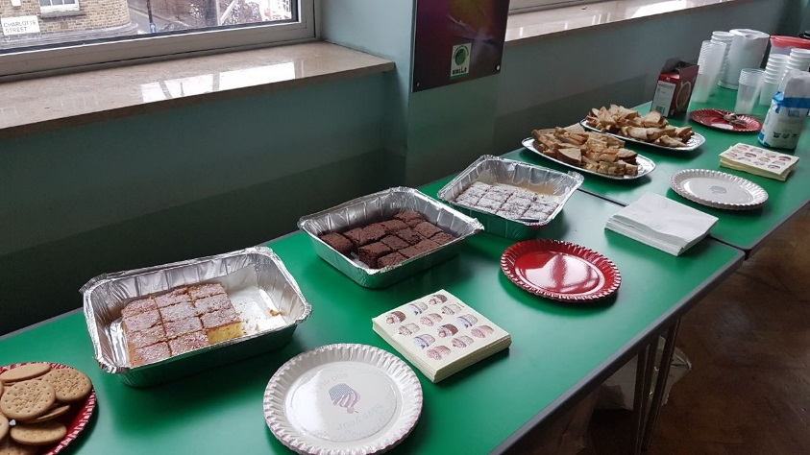

*Figure 5:* Sisters Afternoon Tea at Goodge Street Mosque, London

# Conclusion

## 1.      How IAM 2017 went

Overall, IAM 2017 proved to be incredibly successful for the Central London Working Group. Compared to 2016, where only two events were organised, it is clear that MEND’s Central London Working Group worked proactively to secure as many venues as possible for their Islamophobia Awareness Exhibitions, with this extending past the usual university setting.

Furthermore, by merging the ‘Causes & Cures for Islamophobia’ presentation with the self - defence class they demonstrated how the theoretical could be combined with the practical element of defending one’s self against all forms of hate crime. When considering this in reference to the larger aims of what MEND hopes to achieve, it becomes clear that these events not only encouraged Muslims to be more involved in local politics but also to support MEND in its aims. The willingness of universities and other institutions like hospitals to host these exhibitions and the large turnout at such events demonstrates how MEND is establishing itself as a legitimate representative body for the Muslim community. By working with existing structures and institutions, not only is it encouraging better dialogue between the Muslim and non - Muslim community, but also demonstrating how progress can be made by using existing legal and social frameworks, thus showing its success on both a local and wider level.

# Appendix

## Table of Events during IAM2017

|  |  |  |
| --- | --- | --- |
| **Event** | **Venue** | **Date** |
| Islamophobia Awareness Month (IAM) Exhibition | Whittington Hospital, London | 4/11/2017 |
| Ilmfest Conference IRU Stall | O2, Greenwich. | 4/11/2017 |
| IAM Exhibition | SOAS, University of London | 6/11/2017 to 10/11/2017 |
| Causes and Cures for Islamophobia Presentation | Al - Manaar, London | 11/11/2017 |
| Self Defence Class for Sisters | Al - Manaar, London | 11/11/2017 |
| IAM Exhibition | Kings College London | 13/11/2017 to 14/11/2017 |
| IAM Exhibition | Queen Mary University, London | 20/11/2017 to 24/11/2017 |
| IAM Exhibition | University College London | 22/11/2017 to 24/11/2017 |
| Causes and Cures for Islamophobia Presentation | Queen Mary University, London | 24/11/2017 |
| Sisters Afternoon Tea [1] | Goodge Street Mosque, London | 16/12/2017 |

1. **It should be noted that although this event took place outside of the official IAM November month, the event was planned and organised to take place then, however, due to logistical issues this was executed in December.**