
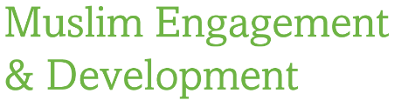

DATE

Dear ……….

Assalamo Alaykum, warahamatullahi wa barakatuhu

I am writing to you in my capacity as a volunteer for the local East London working group of MEND (Muslim Engagement and Development – www.mend.org.uk). MEND is a leading national organization dedicated to tackling Islamophobia and is 100% community-funded.

As you know Islamophobia recently rose by 70% per annum in London alone. Physical and verbal attacks against Muslims (mainly Muslim women) are now very common. Moreover, media negativity against Muslims is at an all time high too. Add to this, the Government’s recent counter terrorism legislation which allows for passports to be seized of British nationals as well as the badly-designed PREVENT programme becoming a statutory requirement further fuelling suspicion against Muslims unfortunately.

MEND seeks to change all this insha’Allah by teaching British Muslims how to hold the media to account and how to redress the deficiencies in law which currently unfairly impact upon British Muslims. We do this by working with mosques, community centres, your local police force, local councils and grass roots Muslims. Most recently, MEND’s work was recognized by the World Economic Forum as an example of ‘best practice and partnership’ in relation to human rights protection and promotion.

In relation to this I would like to request a meeting with yourself on XXXXXXXX to discuss how MEND can work with yourself/your mosque to tackle Islamophobia and for the betterment of the local community. Please kindly let me know if you are available at the above time.

In the meantime, I enclose some literature on MEND for your perusal.

Kind Regards

Imran Patel
VOLUNTEER
MEND East London Working Group

